Rodsley & Yeaveley Parish Council
Dear Residents,
You are invited to attend the meeting of Rodsley & Yeaveley Parish Council to be held on the 15th September 2019 at 7.30 in The Yeaveley Arms.
Members are asked to complete the Declarations sheet (if appropriate) provided at the meeting.
Yours sincerely

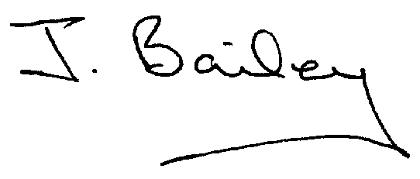Agenda
- Apologies
- Declaration of Members Interests.
  - Members must ensure that they complete the Declarations of Interest Sheet prior to the start of the meeting and must indicate the action to be taken (i.e. to stay in the meeting, to leave the meeting or to stay in the meeting to make representations and then leave the meeting prior to any consideration or determination of the item)
  - Where a Member indicates that they have a prejudicial interest, but wish to make representations regarding the item before leaving the meeting, those representations must be made under the item Public Participation
The Declarations of Interests will be read out from the Declaration Sheet – Members will be asked to confirm that the record is correct.

- Public Participation. This is for maximum 30 minutes – no person to speak for more than 5 minutes.
- Minutes of the Last Meeting
- Neighbourhood Watch
- Planning Application, Stydd Hall Farm, Agricultural Worker’s Dwelling.
- Planning Application, Two Storey Side Extension, The Firs, Rodsley Lane, Yeaveley
- Planning Application, Erection of Dwelling, Land at Cross Roads, Rodsley.
- Planning Application, Bay Tree Farm, Rodsley Lane, Rodsley
- Planning Application, The Park, Wyaston Road, Yeaveley- single storey rear extension, porch and triple garage.
- Panning Application, Ash Tree Farm, Rodsley, extension to existing livestock building.
- Planning Application, The Cottage, Hales Green, Two storey and Single Storey Extensions and Dormer Window.
- Planning Application, The Cottage, Hales Green, extension to garage to form first floor and workshop.
- Planning Application, Honeysuckle Farm, Agricultural Worker’s Cottage (resubmission).
- Waste Bin in Yeaveley and Rodsley.
- Footpath Issues
- Highways and Flooding Issues
- Snow Wardens
- Clerk’s Report
- Financial Matters
- Date of the Next Meeting.

